Lipid clinic and lipoprotein disorders service
Document 3: PCSK9 injections: Alirocumab 75/150mg and Evolocumab 140mg fortnightly
Rationale for administration of PCSK9 inhibitors fortnightly subcutaneous injections:
- For those with primary hypercholesterolaemia or mixed dyslipidaemia in patients who have not responded adequately to a statin or other lipid lowering medication and meet the criteria below.
- For those with primary hypercholesterolaemia or mixed dyslipidaemia in patients who are intolerant to a statin and/or other lipid lowering medication and meet the criteria below.
- For those with primary hypercholesterolaemia or mixed dyslipidaemia in patients where a statin is contraindicated and meet the criteria below.
- Homozygous Familial Hypercholesterolaemia (evolocumab 420mg fortnightly).

NICE TAs (TA393 & TA394) criteria for referral for PCSK9 inhibitors:
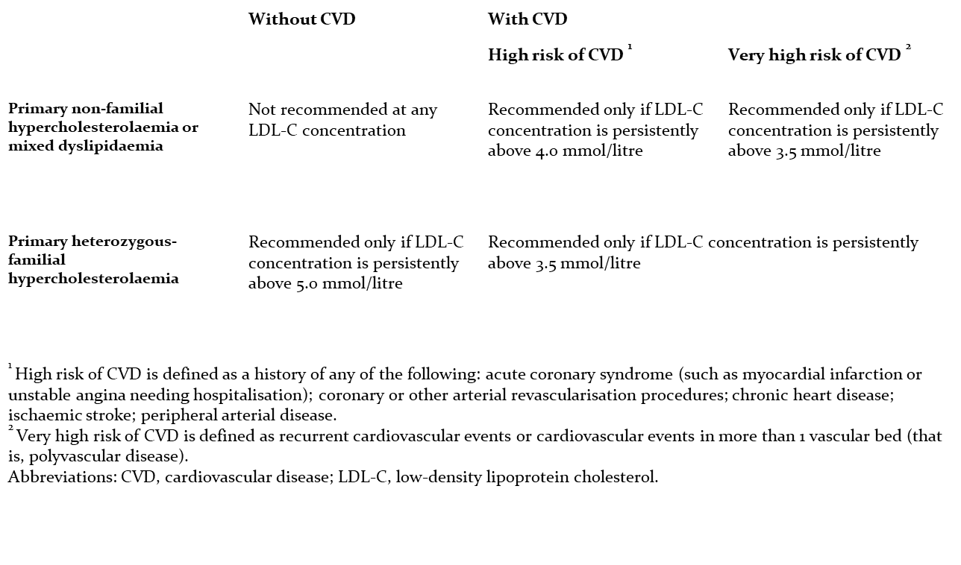
Persistently is defined as 2 consecutive LDL cholesterol readings that meet the criteria at least 3 months apart.
Procedure for PCSK9 inhibitor treatment:
- Above criteria met and blueteq form completed by lipid specialist nurse and approved by CCG.
- First appointment: education and training on how to inject provided to the patient by lipid specialist nurse.
- First appointment: injection self-administered by patient under observation, baseline bloods taken (lipid profile, liver profile, creatine kinase, renal profile, HbA1c).
- Second appointment* – 2 weeks: discuss side effects, if any. Second injection self-administered by patient under observation. Follow up bloods taken (lipid profile, liver profile, creatine kinase, renal profile, HbA1c).
- 3 month supply of injections and sharps bin given to the patient and registration form for homecare signed.
- Signed up for homecare.
- Follow up 6 monthly with bloods (lipid profile, liver profile, creatine kinase, renal profile, HbA1c) until lipid profile stable, then 12 monthly**.

*Changes/adaptations in the light of COVID-19 epidemic (reasonable but not ideal):
Can send the 2nd injection home with the patient if comfortable and if no concerns postpone bloods for 3 months and register for homecare for further supply immediately (if feasible and the patient is comfortable with this). Telephone follow up.
** These can be done as telephone clinics to make sure no clinical issues. Ideally with bloods done at the GP surgery.
Arrange next lipid clinic assessment as soon as possible after the current crisis.
If any urgent clinical issues, will discuss with the consultant and assess if a face-to face assessment needed or referral to other specialities.
Advice to patients: DO NOT change or stop your regular medications without discussion with your consultant or specialist nurse.
Rationale for patients to initially attend the hospital for PCSK9 injections and follow up:
- These patients are usually high or very high CVD risk, has genetic dyslipidaemia and have comorbidities
- Education and training and chance to observe injection technique. Trust has not signed up for the patient support programme.
- Chance to discuss possible side effects.
- Review medications and medical history.
- Need to assess compliance and benefit as PCSK9 MABs are high cost drugs
- Secondary care only prescription.

Benefits of PCSK9 injections (patients treated with these agents are high or very high cardiovascular risk patients):
- Lowers LDL cholesterol by approximately 50-60% in those also treated with a statin.
- Lowers LDL cholesterol by approximately 40-50% in those who take solely the PCSK9 injections.
- Lowering LDL cholesterol by 1 mmol/L reduces atherosclerotic cardiovascular risk by 22% both primary and secondary prevention.
- Lowers lipoprotein (a) by ~25%.
- Odyssey outcomes trial – treating with alirocumab resulted in a lower incidence of recurrent ischaemic cardiovascular events compared to placebo in those patients who have had a previous cardiovascular event and high cholesterol. Inhibition of PCSK9 Monoclonal antibodies on a background of statin therapy reduced the risk of cardiovascular events significantly, both in primary prevention (SPIRE study) and in secondary prevention (FOURIER and SPIRE studies).

Possible side effects from PCSK9 inhibitors (generally very similar for the two PCSK9 MABs licensed):
- Injection site reactions (bruising, bleeding) – 3.3% ( evolocumab PROFICIO study)
- ‘Flu like’ symptoms/influenza 5.9% (alirocumab, similar compared to control group 4.9%), nasopharyngitis - 6% (evolocumab PROFICIO study similar to control group 5%), upper respiratory tract infections - 3% (evolocumab PROFICIO study similar to control group 3%)
- Headache – 3% (evolocumab PROFICIO study)
- Back pain – 3% (evolocumab PROFICIO study)

